Name: ______________________________________ Date:_________________ Period: _____
Created by Camilia Rowshan and Daniel Lee

Chapter 1: Matter, Measurement, and Problem Solving Study Guide

Key Terms
Atoms | Basic unit of chemical element
Molecule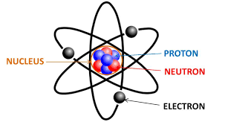 | Group of atoms bonded together
Scientific Law | Generalization about nature that summarizes past observations and predicts future ones (the WHAT)
Theory | A model mas on a well-established hypothesis and is validated by experimental evidence (the HOW and WHY)
Law of Conservation of Mass | (Lavoisier) In a chemical reaction, matter is neither created nor destroyed
Atomic Theory  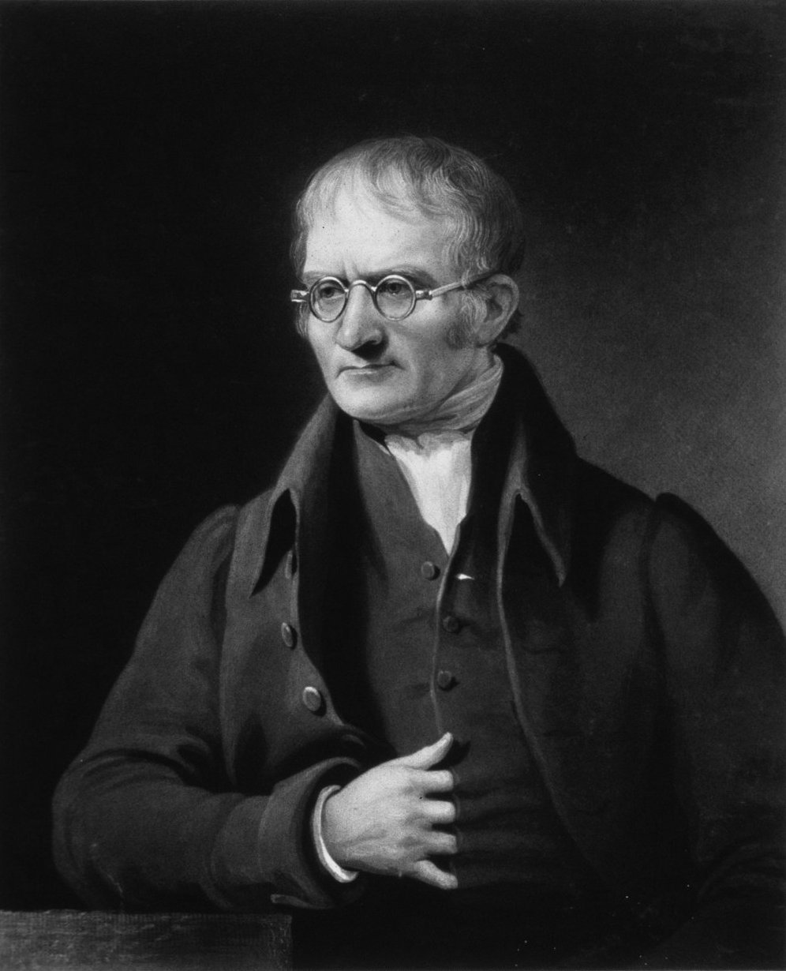 | (Dalton)  - All matter is made of atoms. Atoms are indivisible and indestructible  - All atoms of a given element are identical in mass and properties  - Compounds are formed by a combination of two or more different kinds of atoms  - A chemical reaction is a rearrangement of atoms  **Modern science has proved that we can destroy atoms via nuclear reactions and that there are different kinds of atoms within an element (isotopes)
Matter | Anything that occupies space and has mass  → Matter is classified by its state (solid, liquid, or gas) and its composition
Substance | A specific instance of matter (ex. Air, water, or sand)
Energy | The capacity to do work
Work | Force applied over a distance
Kinetic energy | Energy associated with motion
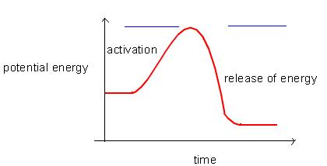Potential energy | Energy associated with position or composition
Thermal energy | Energy associated with the temperature of an object
Law of Definite Proportions | All samples of a given compound, regardless of their source or how they were prepared, have the same proportions of their constituent elements
Cathode Rays | A beam of electrons emitted from the cathode of a high-vacuum tube
Cathode Ray Tube | A partially evacuated glass tube
Electrical Charge | A fundamental property of some of the particles that compose atoms and results in attractive
Electron | A negatively charged, low mass particle present within all atoms
Radioactivity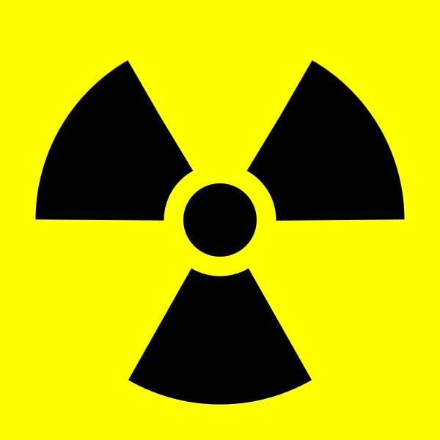 | The emission of small energetic particles from the core of certain unstable atoms
Nuclear Theory | - Most of the atom’s mass and all of its positive charge are contained in the nucleus  - Most of the volume of the atoms is empty space where negatively charged electrons are dispersed  - There are as many electrons outside the nucleus as there are protons within the nucleus, so the atom is electrically neutral
Natural Abundance | Percentage of each different isotope in a natural occurring sample of a given element
Ion | Charged particle  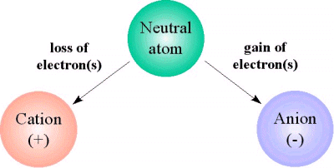
Periodic Law | The chemical and physical properties of the elements recur periodically when the elements are arranged in the order of their atomic weights
Mass Spectrometry | A technique that separates particles according to their mass to measure the masses of atoms and the percent abundances of isotopes of elements
Law of Multiple Proportions | When two elements form two different compounds, their individual masses can be expressed as a ratio of small whole numbers
Isotope | Atoms of the same element having different numbers of neutrons are different isotopes of that element; The atomic mass of an element is calculated by averaging the atomic masses of the isotopes of that element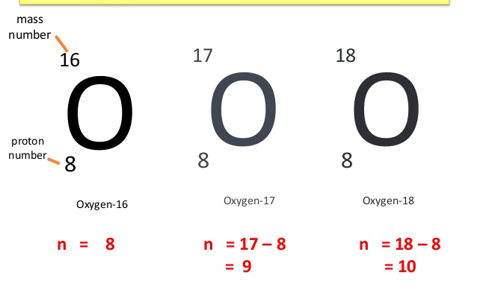
Aufbau Principle | Electrons fill lower energy levels before they fill higher ones
Hund’s Rule | Every orbital in a sublevel must fill with one electron before a second electron of opposite spin can be added to any orbital in that sublevel
Pauli Exclusion Principle | Requirement that no two electrons in an atom have the same set of four quantum numbers in an atom have the same set of four quantum numbers
Paramagnetic vs. diamagnetic | Paramagnetic elements have unpaired electrons, while diamagnetic elements do not  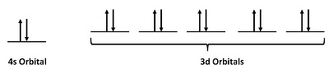

Periodic Trends
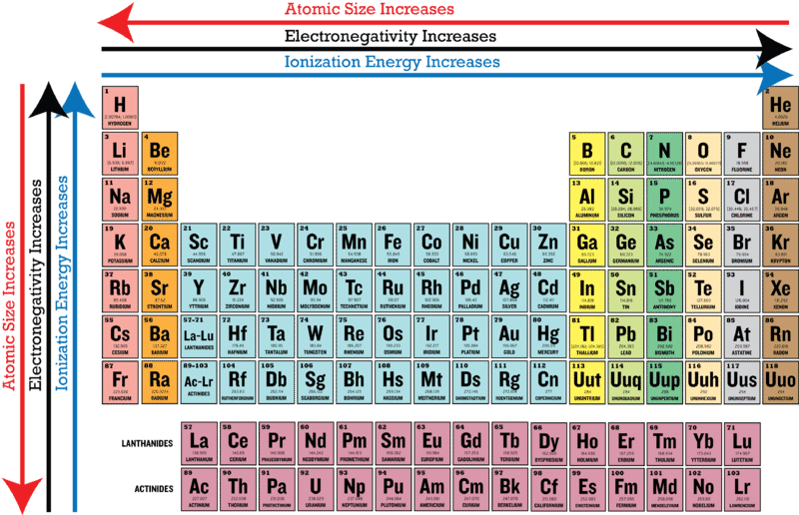

Physical Change vs. Chemical Change
Physical Change | Chemical Change
Is an alteration of state, appearance, or quantity; composition does not change | Is a rearrangement of atoms or alteration of composition

Physical vs. Chemical Changes Practice:
Classify each of the following as a physical or chemical change.
- The distillation of salt water to produce pure water. ____________________
- The rusting of an iron nail. ____________________
- The burning of wood in a fireplace. ____________________
- Salt precipitating out of a solution. ____________________

Answer Key:
- Physical (the water is changing states)
- Chemical (iron reacts with oxygen to form iron oxide)
- Chemical (a combustion reaction is occurring)
- Physical (the salt is changing states)

Separation Techniques

Decanting | 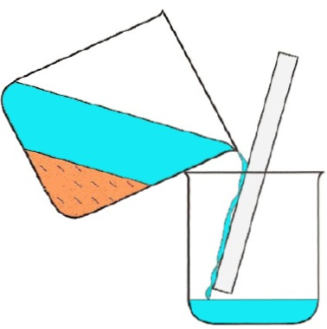
Distillation | 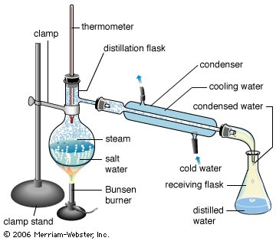
Filtration | 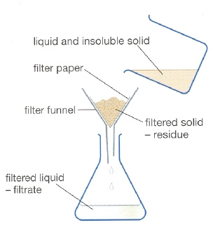
Chromatography | A method of separating and analyzing mixtures of chemicals based on their bonds and polarity  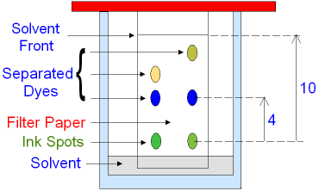
Evaporation | 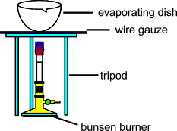

Crystalline and Amorphous Solids
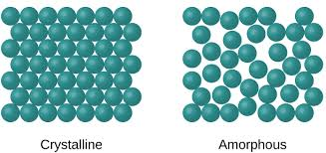
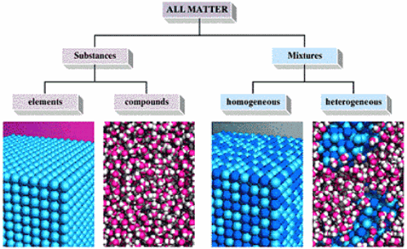

Solids, Liquids, and Gases
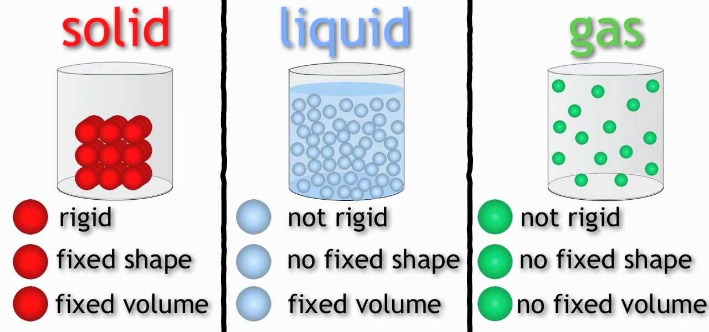

Energy
- Most physical and chemical changes create an energy change
- Total energy = kinetic energy + potential energy
- Law of Conservation of Energy: Energy cannot be created nor destroyed, but it can change form and flow from one object to another
- Systems with high potential energy tend to change in a way that lowers their potential energy
  - Low potential energy is generally more stable than high potential energy

Extra practice
Phet Simulation of Energy: https://phet.colorado.edu/en/simulation/legacy/energy-forms-and-changes

Crash Course: Energy & Chemistry
https://www.youtube.com/watch?v=GqtUWyDR1fg&index=17&list=PL8dPuuaLjXtPHzzYuWy6fYEaX9mQQ8oGr

Temperature
- Fahrenheit (°F): water freezes at 32° and boils at 212°
- Celsius (°C): water freezes at 0° and boils at 100°
- Kelvin: 0 is the coldest temperature possible (absolute zero)
- °C = (°F - 32)/1.8
- K = °C + 273.15

Derived Units
- Come from combinations of base units (ex. mol/L or g/mol)
- Volume (V): measures space
  - Base unit for volume: m^3
  - 1 L = 1000 mL = 1000 cm^3 = 1.001 m^3
  - Extensive property (depends on sample size or amount of substance)
- Density:
  - d=m/V
  - SI base unit: kg/m^3
  - Common unit: g/mL for solids and liquids
  - g/L for gases
  - Intensive property (independent of sample size or amount of substance)

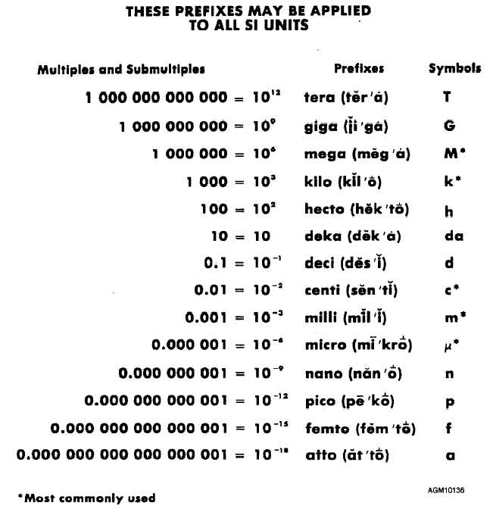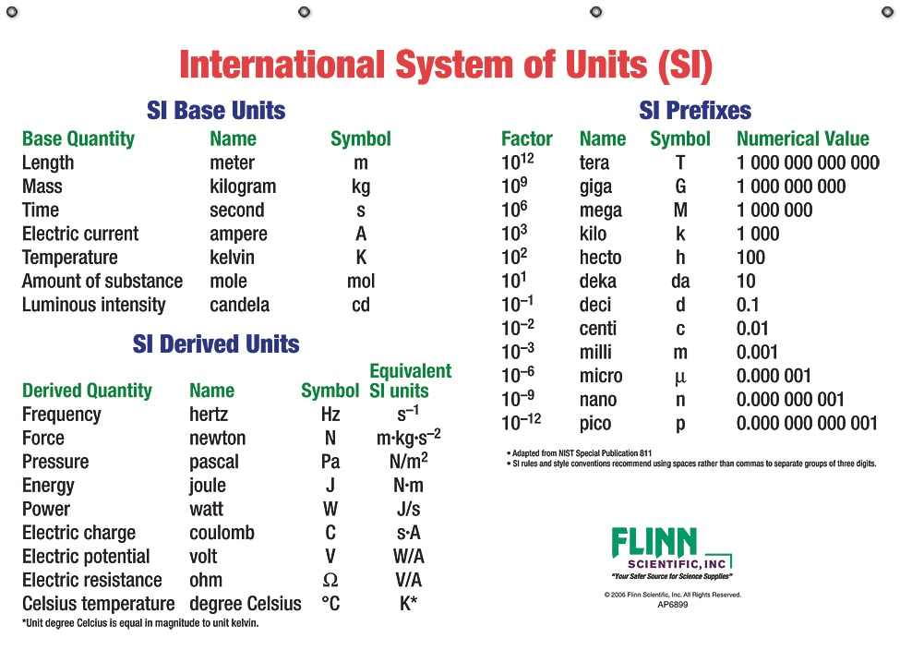

Units Conversion Practice
The average temperature of the human body is 98.6°F. Convert this into °C and K.
  - ____________________

Solution:
°C = (98.6°F - 32)/1.8 = 37.0°C + 273.15 = 310.2 K

Significant Figures
- Every digit is certain except the last, which is uncertain
- All non-zero digits are significant
- All zeros after a non-zero digit are significant
- Leading zeros are not significant
- Trailing zeros in a non-decimal number are not significant
- When multiplying and dividing, use the LEAST number of sig figs
- When adding and subtracting, use the LEAST precise number of sig figs

Convert the following measurements into numbers between 1 and 10 using prefix multipliers.
- 1908750 m
  - ____________________
- 0.00000000000989 s
  - ____________________
- 6.8526 x 10⁻6 g
  - ____________________
- 0.06548 m
  - ____________________
- 4.548 x 10³ g
  - ____________________

Solutions:
- 1.90875Mm
- 9.89 ps
- 6.8526 μg
- 6.548 cm
- 4.548 kg

Precision and Accuracy

Precision | Accuracy
How close a series of measurements are to one another | How close the measured value is to the actual value

- Random errors: have an equal probability of being higher or lower than the true value. These errors can be reduced by finding the average of the measures
- Systematic errors: Cause results that are either too high or too low and do not average out with multiple measurements. They cause results that are inaccurate, but they do not affect precision

Dimensional Analysis
Step 1: Identify whether you should use stoichiometry or an equation
2: Identify given information
3: Identify what you are trying to find
4: Plan out how you are going to solve… units can be used as a guide
5: Plug in values
6: Solve

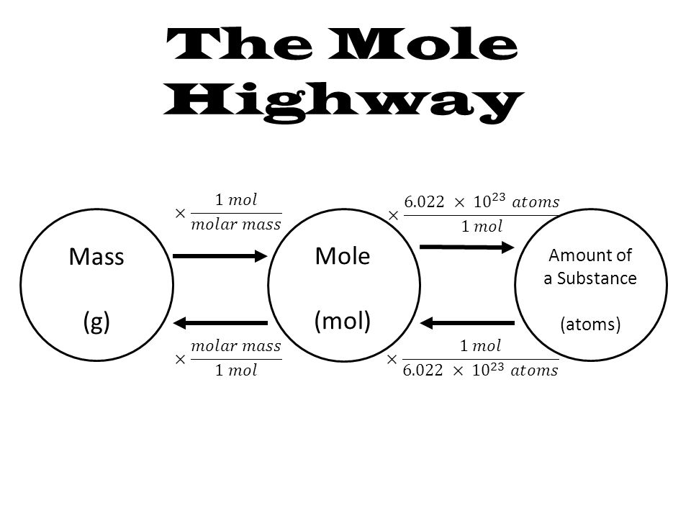

Empirical and Molecular Formulas
- The empirical form represent the simplest ratio of one element to another in a compound, while the molecular formula represents the actual formula for the substance

Multiple Choice Questions
- Which of the following has the greatest percent by mass of carbon?
  - HCN
  - CH₄
  - CO₂
  - CO

2. Ordinary bleach is 5.25% NaOCl by mass with a density of 1.11 g/ml. How many grams of NaOCl are in 50 mL of bleach
- 5.82g
- 2.91g
- 275g
- 11.5g

3. The halogen in this group is
- Bismuth
- Strontium
- Uranium
- Bromine

4. Which pair of elements is expected to have the most similar properties?
- Potassium and lithium
- Sulfur and phosphorus
- Silicon and carbon
- Lithium and magnesium

5. The number of electrons, protons, and neutrons in argon-40 is
  - 18 e, 18 p, 40 n
  - 40 e, 40 p, 18 n
  - 18 e, 22 p, 18 n
  - 18 e, 18 p, 22 n

6. Which of the following best explains the relative positioning and intensity of the 2s peaks in the following spectra?
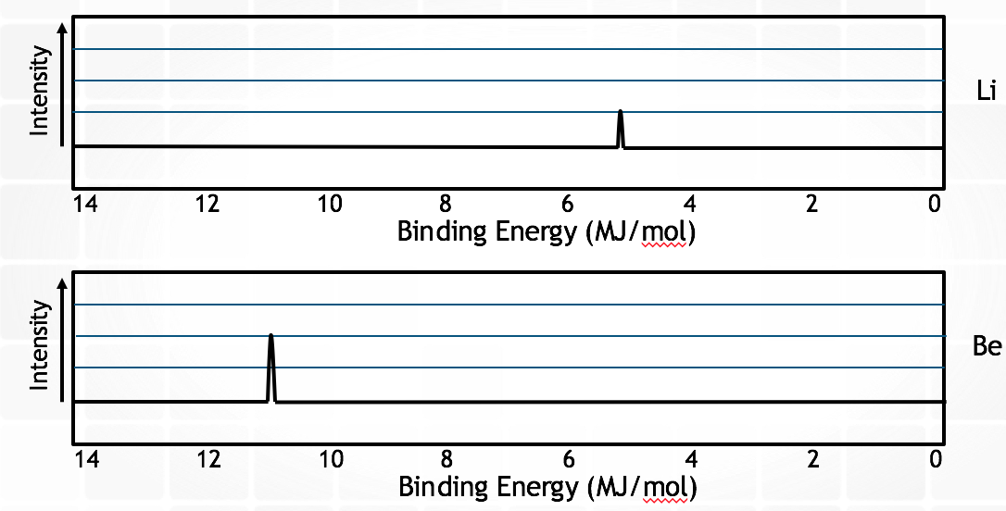

- Be has a great nuclear charge than Li and more electrons in the 2s orbital
- Be electrons experience greater electron-electron repulsions than Li electrons
- Li has a greater pull from the nucleus on the 2s electrons, so they are harder to remove
- Li has greater electron shielding by the 1s orbital, so the 2s electrons are easier to remove

7. How many protons, neutrons, and electrons are in an atom of bromine?
- 35 p, 45 n, 35 e
- 45 p, 35 n, 45 e
- 80 p, 35 n, 80 e
- Neutrons cannot be determined unless the isotope is specified.

8. Which of the following is LEAST likely to have allotropes?
- S
- P
- H
- Se

9. Which element could be represented by the complete PES spectrum below?
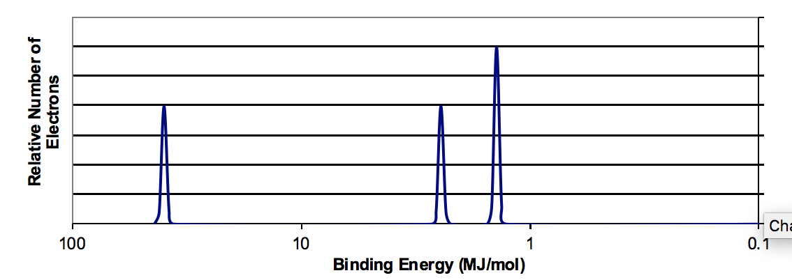
- Li
- B
- N
- Ne

10. Which of the following elements has its highest energy subshell completely full?
- Sodium
- Aluminum
- Chlorine
- Zinc

Multiple Choice Answers:
- B
- B
- D
- D
- D
- A
- D
- C
- C
- D

Free Response

- A hydrate of magnesium chloride is present and the following data is collected.

Mass of crucible | 22.130 g
Mass of crucible + hydrate | 25.290 g
Mass of crucible and contents after heating | 23.491

- Calculate the mass of hydrate ________________________________________________________________________________________________________________________________________________________________________________________________________________________
- Calculate the mass of anhydrate ________________________________________________________________________________________________________________________________________________________________________________________________________________________
- Calculate the mass of water lost ________________________________________________________________________________________________________________________________________________________________________________________________________________________
- Calculate moles of Magnesium Chloride used ________________________________________________________________________________________________________________________________________________________________________________________________________________________
- Calculate moles of water lost ________________________________________________________________________________________________________________________________________________________________________________________________________________________
- Find the mole ratio of magnesium chloride to water ________________________________________________________________________________________________________________________________________________________________________________________________________________________
- What is the formula of the hydrate? ________________________________________________________________________

  - List two possible sources of error in this lab ______________________________________________________________________________________________________________________________________________________________________________________________________
  - What effect would these errors have on the lab calculations and analysis? ________________________________________________________________________________________________________________________________________________________________________________________________________________________________________________________________________

2.
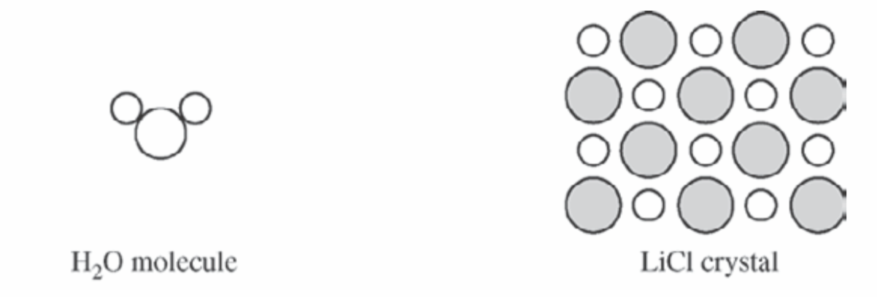
The structures of a water molecule and a crystal of LiCl (s) are represented above. A student prepares a 1.0 M solution by dissolving 4.2 g of LiCl (s) in enough water to make 100 mL of solution.
- In the space provided below, show the interactions of the components of LiCl (aq) by making a drawing that represents the different particles present in the solution. Base the particles in your drawing on the particles shown in the representations above. Include only one formula unit of LiCl and no more than ten molecules of water. Your drawing must include the following details.
  - Identity of ions (symbol and charge)
  - The arrangement and proper orientation of the particles in the solution
Answers to FRQs:

  - Mass of hydrate = 25.290 g - 22.130 g = 3.160 g
  - Mass of anhydrate: 23.491 g - 22.130 g = 1.181 g
  - Moles water lost: 3/160 g - 1.181 g
  - Moles of MgCl₂ used: 1.181 g / 95.211 g/mol = 1.240 mol
  - Moles of water lost: 1.979 g/18.015 g/mol = 0.20985 moles water
  - Mole ratio of magnesium chloride to water = 1:11.3
  - MgCl₂ · 12H₂O

- Answers will vary

    - Can include not cleaning the crucible before weighing it or not drying it after cleaning it
    - Not cleaning the crucible before weighing may cause there to be contamination, which would affect the magnesium chloride calculated yield. Not drying it after cleaning it would increase its measured mass and therefore decrease the calculated amount of magnesium chloride.

2.
