Unit 1 Study Guide

By: Benjamin Fan, Jake Gordon

The states of matter: Solid, Liquid, and Gas
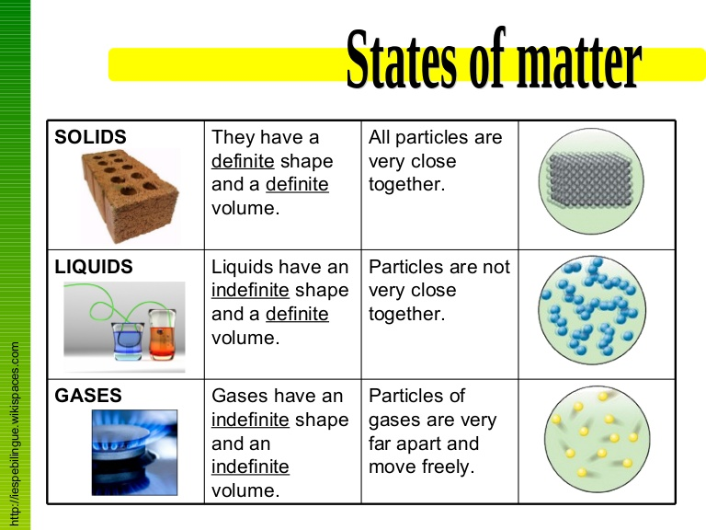Classifying matter according to composition
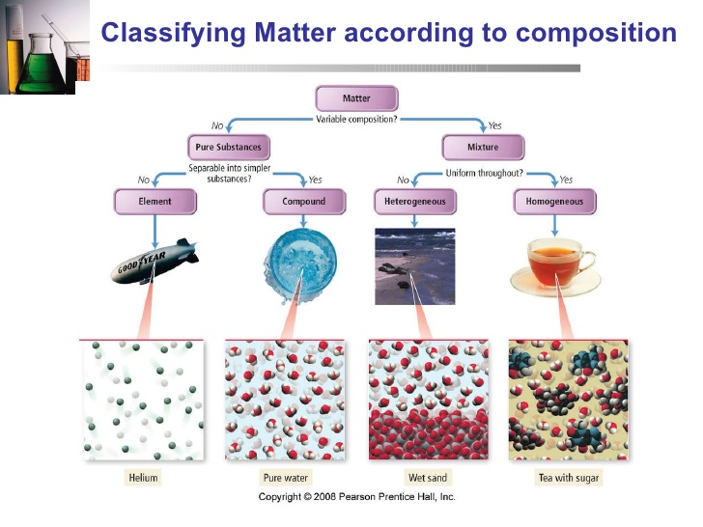
Separating Mixture
To separate a mixture into its components, chemists have many different ways. In general, mixtures are separable because the different components have different physical or chemical properties.

- Decanting-- carefully pouring off the liquid into another container to obtain the undissolved solid.
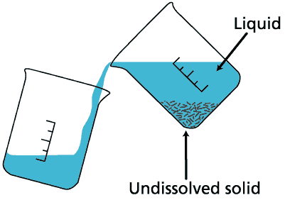
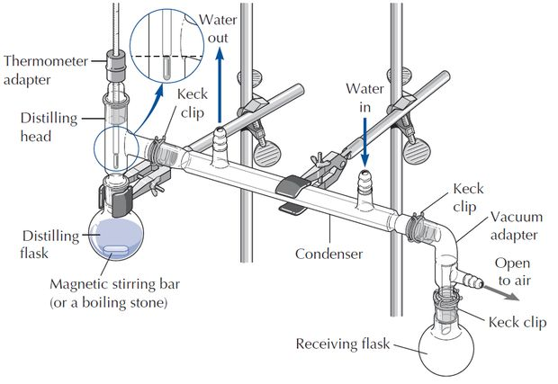
- Distillation --- a homogeneous mixture of liquids can usually be separated by it, a process in which the mixture is heated to boil off the more volatile(easily vaporizable) liquid.

- Filtration --- a mixture is composed of an insoluble solid and a liquid, we can separate it by filtration. The mixture is poured through filter paper in a funnel.

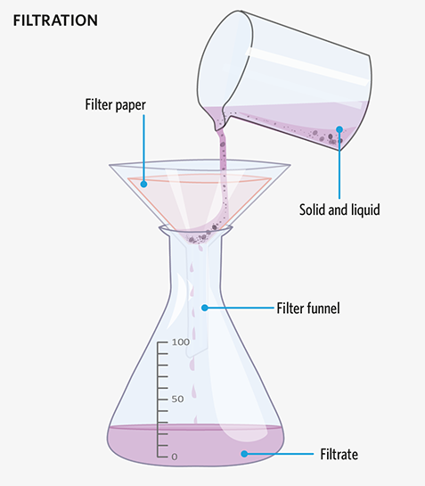

Physical and chemical changes
Changes that alter only state or appearance, but not composition, are physical changes. The atoms or molecules that compose a substance do not change their identity during a physical change.
Changes that alter the composition of matter are chemical changes. During a chemical change, atoms rearrange, transforming the original substances into different substances.
A physical property is a property that a substance displays without changing its composition, whereas a chemical property is a property that a substance displays only by changing its composition via a chemical change

The Units of Measurement: International System of Units 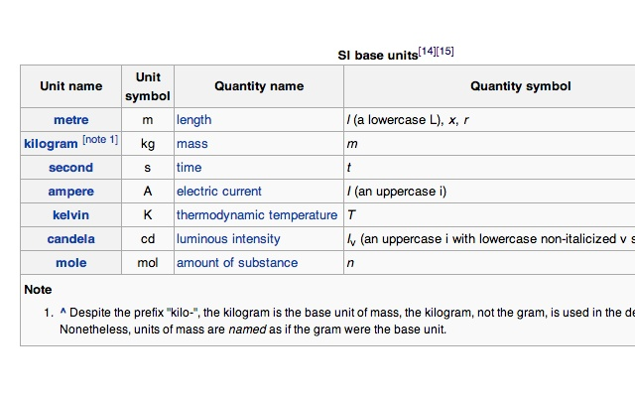
The SI unit for temperature is the Kelvin.
℃ = $\frac{(℉-32)}{1.8}$
K = ℃ + 273.15

Prefix Multipliers

Volume, Mass and Density

Volume: the amount of space that a substance or object occupies, or that is enclosed within a container. Ex: cubic meter ($m^{3}$)
The density of a substance is the ratio of its mass (m) to its volume (V):

Density = $\frac{mass }{volume}$, D = $\frac{m}{V}$

Significant Figures

When taking measurements in lab, your measurement will always have a certain number of significant figures. For example, using a balance to measure the weight of an object to the hundredths place, we might get 23.15 g. That number has four significant figures. The balance is no more accurate than that; we can not say the mass of the object is 23.15224 g.

- For numbers without a decimal place, you count every number except for trailing zeroes ( those which appear after all non-zeroes). So, 105 g has three significant figures, the zero in that measurement does not trail all other numbers.
- For numbers with a decimal place, you count every number except for leading zeroes (those which appear before all non-zeroes). The number 0.052 has 2 sig figs, but 0.0520 g would have three (trailing zeroes DO count in numbers with decimals).
When doing calculations, any calculated value cannot be more accurate than the measurements used on the calculation.

- When multiplying and dividing, the answer cannot have more sig figs than the least accurate measurement.
For example: 2.50 g / 12 ${cm}^{3}$= 0.20833 g/${{cm}^{3}}^{}$is wrong. The two measurements have three sig figs and two sig figs, respectively. The answer cannot have five. It has to have only two because that’s how many figures the least accurate measurement had. The correct answer is 0.21 g /${cm}^{3}$.
- When adding and subtracting, the answer cannot have more figures after decimal place than the value with the least number of figure after its decimal place. For example:
1.435 cm + 12.1 cm = 13.535 cm is wrong. The values have three figures after decimal and one figure after decimal, respectively. The answer cannot have more than one figure past the decimal, because that’s how many figures the least accurate measurement had. The correct answer is 13.5 cm.
Solving Chemical Problems

- Write the conversion as a fraction (that equals one)
- Multiply it out (leaving all units in the answer)
- Cancel any units that are both top and bottom.

Example 1:
Let's start with a simple example: convert 3 km to m (3 kilometers to meters). There are 1000 m in 1 km
The layout is:
- Write the conversion as a fraction
- Multiply
- Cancel any units that are both top and bottom
You can write the conversion as a fraction that equals 1:
1000 m1 km = 1
And it is safe to multiply by 1 (does not affect the answer) so we can do this:
3 km x $\frac{1000m}{1km}$= $\frac{3000 km ⋅ m}{1 km}$
We can "cancel" any units that are both top and bottom:
$\frac{3000 km ⋅ m}{1 km}$ = 3000 m

General Problem-Solving Strategy
- We must identify what the given information is. Ex: the mass, volume and concentration...etc
- We must know what the answer we look for.
- Find a way to use the given information properly and what you have learned in class to find the answer. (Let the units be your guide!)

Multiple Choice Questions
- Which of the following is a heterogeneous mixture?
A. oxygen gas
B. Ice
C. Salt water
D. Wet sand
- A block of Al occupies a volume of 15.0 ml and weighs 40.5g. What is its density? All answers are in grams per mL
A. 2.7
B. 0.37
C. 3.7
D. 2.856
- What is the electron configuration for ${Sr}^{+2}$?
A. [Ar]
B. [Ne] ${3s}^{2}{3p}^{6}$
C. [Kr]
D. [Kr] ${5s}^{2}{4d}^{ 5}$
- Record 0.0017640 to 3 significant figures
A. 0.001
B. 1.76 $×$ ${10}^{-3}$
C. 1.764$×{10}^{-2}$
D. 0.002
- 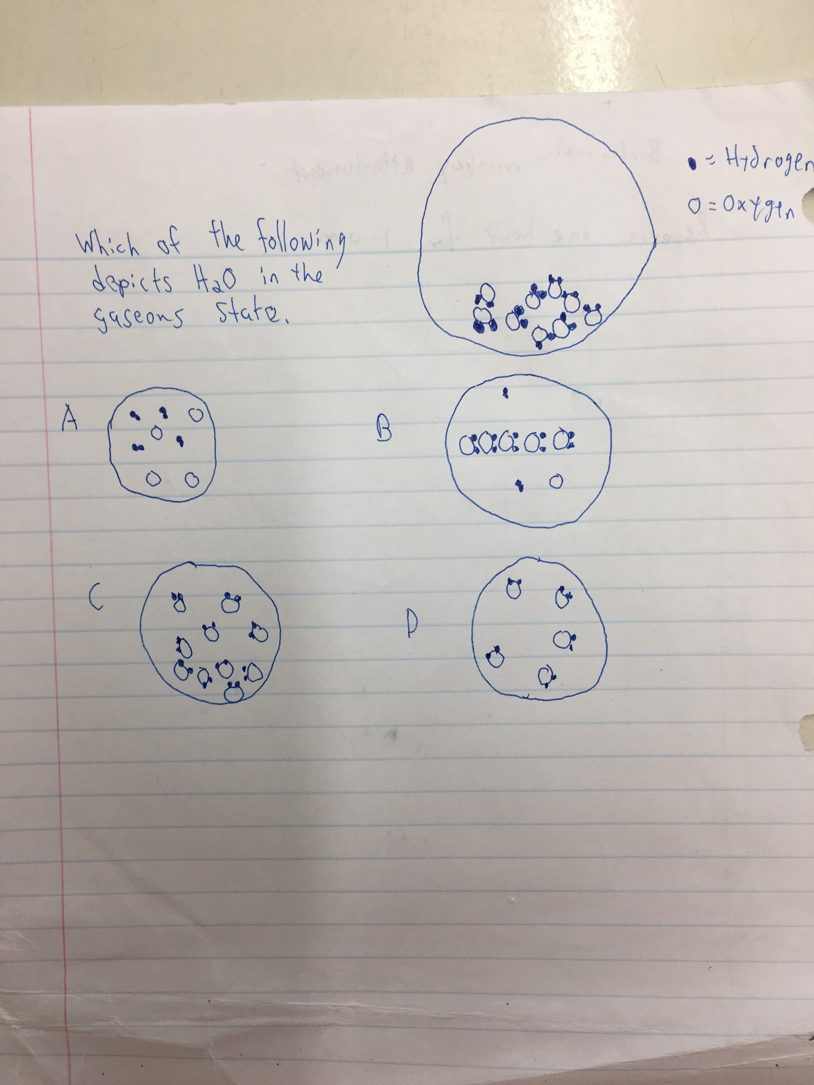
Free Response Questions

- 1a. Label the PES graph by electron configuration in the boxes.
1b. What is the most likely element?
1c. Explain which peak has the strongest energy and why?
2. (Long FRQ) The student is given a 50 ml beaker; they must add 10 g sand, 5 g iron shavings, 12 plastic beads and 5 g salt.
2a. Fill in missing protocol steps
1. Sift the entire mixture this will leave only the beads and larger iron pieces.
2. Take a magnet to remove iron
3. Put beads in a separate beaker
・propose how to separate sand and salt
4.
5.
6.
7. Clean up lab station
Binding Energy (MJ/mol)
Relative Number of Electrons

275
26.8
20.2
2.44
1.25

2b. What type of change is evaporation?
2c. Name one separation technique used.
2d. How can the student check how much mass is lost during the experiment. Include one possible error.

Atoms of an element with different numbers of neutrons are called isotopes. The molar mass given on the periodic table is the average of the mass numbers of all known isotopes weighted by their percent abundance

The mass of various isotopes of an element can be determined by a technique called mass spectrometry.
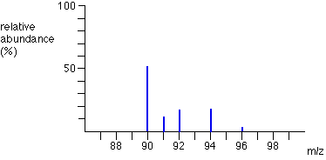

Atomic mass = $\sum_{n}{}$(fraction of isotope n) $×$(mass of isotope n)
Moles and Molecules
1 mole = 6.022 $×{10}^{23}$particles
Moles = $\frac{particles }{(6.022×{10}^{23})}$
Moles and Grams
We can use the relationship between amu and g/mol to convert between grams and moles by using the following equation:

Moles = $\frac{grams }{molar mass}$

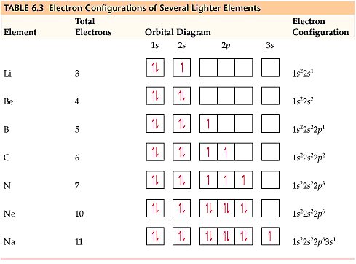

Electron Configuration builds on itself each subshell has a maximum number of electrons. The only tricky part is that the d block will always be one number behind. The 4s subshell shares an energy level with the 3d subshell. The arrows represent opposite spinning electrons.

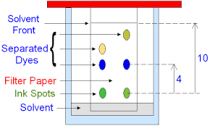This is a rudimentary diagram of paper chromatography; a technique that separates based on whether a substance’s polarity is more like the paper or solvent.

Answer Key

MC

1 D
2 C
3 C
4 B
5 D

Short FRQ

1. 1s 2s 2p 3s 3p

2 Chlorine

3.One point for stating the 1s peak. One point for talking about Coulomb’s law and how there is a greater pull from the nucleus.

Long FRQ

1.Add DI water to the sand and salt mixture
2.Filter with a coffee filter or decant all liquid
3.Use a hot plate to evaporate the water and leave salt

+4 for 3 right +2 for 2 right +1 for 1 right

4 Physical or Phase

5. Filtration or Decanting

6. Weigh each substance before and after mixture, the difference in mass is the mass lost. (Law of conservation of mass) 2 pts

7. 2pts for including 1 logical error Ex} Not waiting for all moisture to drip down after filtration this would lose water and therefore salt would be lost.¿¿

