COMMON MONOATOMIC AND POLYATOMIC IONS
Atoms and groups of atoms may gain or lose electrons to form ions with a positive or negative charge. These ions will combine to form compounds. In order to determine chemical formulas of many ionic compounds you must memorize the following common ions and their charges.

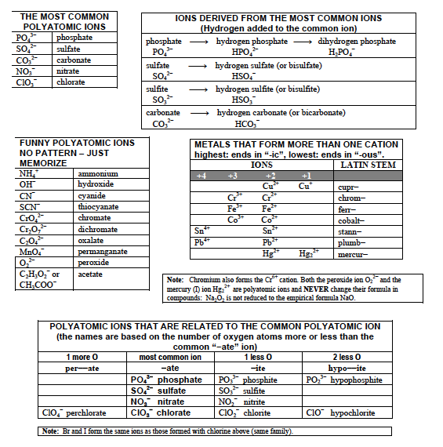
SOLUBILITY RULES
Chemists qualitatively describe substances as soluble, slightly soluble, or insoluble in water. A substance is soluble if it visibly dissolves in water. If not, the substance is described as insoluble. Soluble ionic compounds are strong electrolytes, and will therefore conduct electricity. The solubility rules below classify some common ionic compounds as either soluble or insoluble.
Keep in mind that even insoluble compounds dissolve to a certain extent. There is no such thing as a completely insoluble salt. If a combination of ions forms an insoluble ionic compound, a precipitate will form. A precipitate is a solid that settles to the bottom of a container and remains undissolved.

