Name ________________________________________ Date _________________Period _____
Directions: Using the graph below:
- Determine the percent of each isotope in nature.
- Determine the average atomic mass of this isotope.
*Show ALL of your work. Use the back of this sheet if necessary.

Mass Spectrometry of an Unknown Element
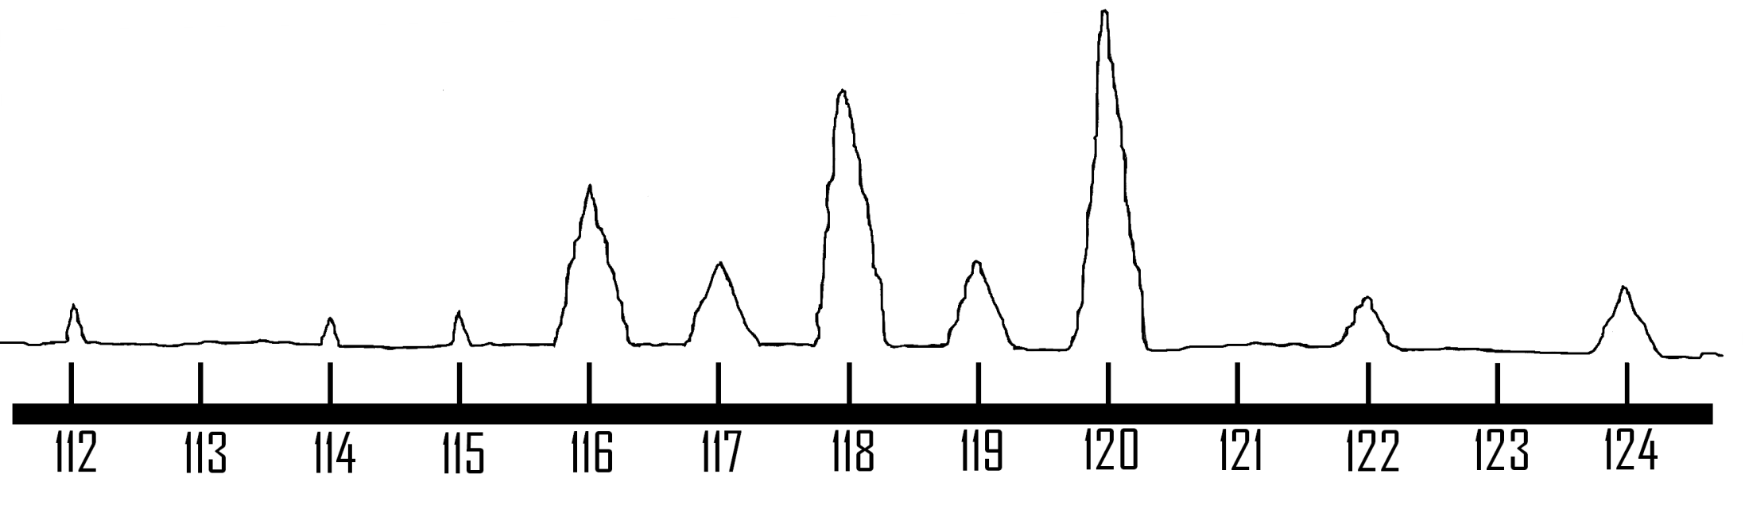
Check for understanding:

- How many isotopes does this element have?

- What is the average atomic mass of this element?

Peak # | Base  (_______) | Height  (_______) | Area  (______) | Percentage

