Introduction: Significant Figures, Measurements and Conversions

Part 1: Rounding Numbers

Rule 1: In a series of calculations, carry the extra digits to the final result, then, round off. DO NOT round off in the middle of a series of calculations.

Rule 2: If the digit to be removed is less than 5, the preceding digit stays the same.

Example: Round off the number 3.24 ___________

Rule 3: If the digit to be removed is greater than or equal to 5 and followed by nonzero digits, the preceding digit is increased by one.

Examples:
1) Round off the number 1.27 ___________

2) Round off the number 4.157 to the tenth place. ___________

Rule 4: If the digit to be removed is equal to 5 and not followed by nonzero digits, the preceding digit is increased by one if it is odd, and remains unchanged if it is even. Statistics show that rounding to an even number is most accurate.

Examples:
1) Round off the number 4.75 ___________

2) Round off the number 6.45 ___________

3) Round off the number 4.0150 to the hundredth place ___________

Part 2: Significant Figures

Examples: How many SIG FIGS are in each of the following numbers?

- 235
- 462.24
- 25
- 0.00952
- 0.001233
- 1005
- 18.057
- 3.0000 x 10⁻⁹
- 1000
- 674.00
- 6.02 x 10²³
12) 1.7 x10¹⁴

Significant Figures in Multiplication and Division

Rule: The number of significant figures in the result is the same as the least number of significant figures used in the calculation.

Examples:
1) 12.65 x 1.3 = ___________

2) 7.451 / 1.23 = ___________

Significant Figures in Addition and Subtraction

Rule: The number of decimal places in the result is the same as the least number of decimal places used in the calculation.

Example:
1) What is the result of 32.53 + 2.7 + 3.091 = ___________

2) What is the result of 11.53 – 2.101 = ___________

Part 3: Accuracy and Precision

Precision is the closeness of values in a set of data. Precision is determined by how well a measurement is replicated.

Accuracy measures the closeness of results to the true value. True value is a scientifically accepted value. Accuracy can be determined by calculating ____________________ or __________________.

Example: On each dartboard drawn below, draw 4 darts to represent the appropriate accuracy and precision values:

High Accuracy Low Accuracy High Accuracy Low Accuracy
High Precision High Precision Low Precision Low Precision

Part 4: The Metric System

Measurement | SI Unit
Length
Mass
Time
Electric Charge
Temperature
Amount of Substance

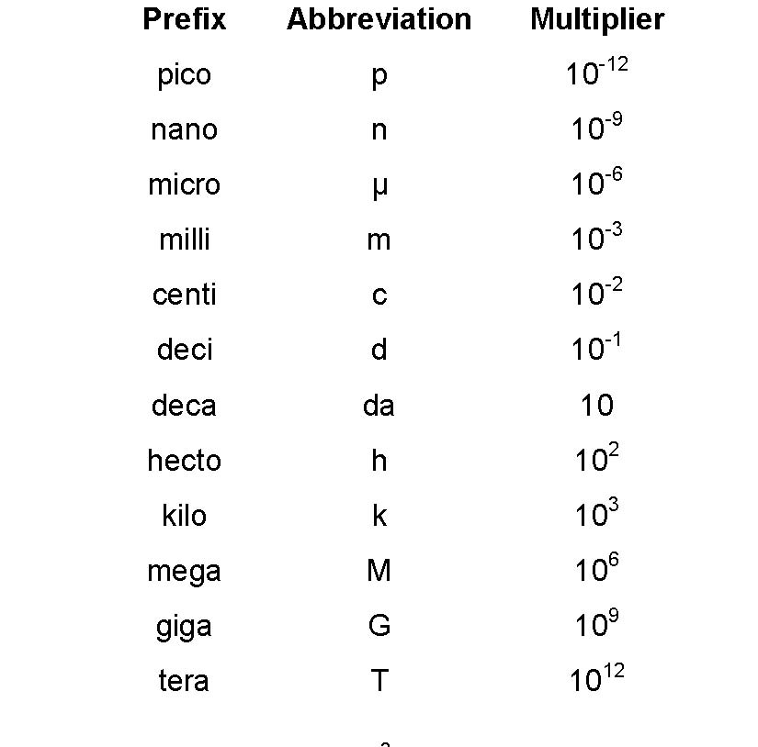

Part 5: Metric Conversions

- The wavelength of an X-ray is approximately 500 pm. Convert this to km.

- It takes 500 seconds for sunlight to travel to Earth. Convert this to ns.

- The Y chromosome is approximately 1.5 μm. Convert this to cm.

Part 6: Volume Conversions
The formula for calculating the volume of a rectangular solid: ____________________

The units for the volume of a solid are therefore _______________ whereas the units of a fluid (_____________ or _______________) are represented as ____________________.

Examples:
1) An Olympic sized swimming pool contains 2.5 x 10⁶ L of water. Convert this to m ³

2) A marble has a volume of 8.5 x 10⁻⁶ m³. How many mL of water will it displace?

3) Determine how many liters of water will be displaced by a rock with a volume of 5.1 mm³
Part 7: Density

The density of a substance depends on 2 factors: ________________ and _________________.

The equation for calculating density is:

Examples:
1) A spherical, helium-filled balloon has a diameter of 21.3 cm. The density of helium is 0.1786 g/L. How many moles of helium are contained within the balloon?

2) A water tower is 6.16 m high and 0.75 m in diameter and is completely filled with water. If the water has a mass of 2.9 x10³ kg, find the density of the water.

Part 8: Temperature Conversions
°F = 1.8 °C + 32
K = °C + 273.15

The 3 common units of temperature are: ____________________, ____________________ and ________________________.

Examples:
- The surface of the sun has a temperature of 5778 K. Convert this value to Celsius.

- The hottest recorded temperature in Death Valley is 134 °F. Convert this value to Celsius

- Room temperature is approximately 21°C. Convert this value to Fahrenheit and Kelvin.

